Exercise: JQuery Mobile
Document Number: |  | Issue Number:  Date:

Exercise 1: Create a basic structure for the web app.

Description
The purpose of this exercise is creating the basic structure of the common mobile web application from beginning.
Note: Use Aptana Studio 3 as development editor

Create new Project.
In Aptana, create new project with default web project.
Provide the project name as ‘JQM_Demo’
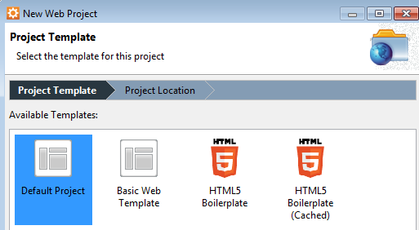
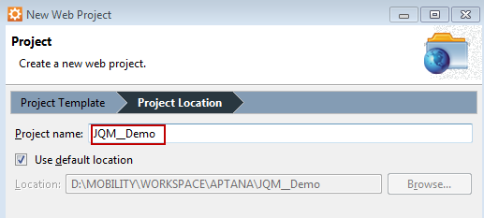

Create the project file structure
- Create two html file in root folder, named master.html and details.html
- Create new folder ‘images’ and put logo.gif inside it
- Create new folder ‘scripts’ and create a blank javascript file inside, named main.js
- Create new folder ‘styles’ and create a blank css file inside, named main.css
- Create new folder ‘jsons’ and create a blank file inside, named contacts.js
The overall structure will look like the image below
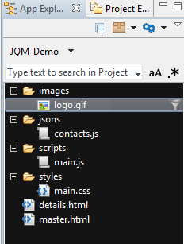

Adding jQuery and jQuery Mobile library
- Two files master.html and details.html already have some default generated code in the header section. Keep it there and add some additional files for jQuery/jQuery Mobile library and our own javascript / css in the header section.
<link rel="stylesheet" href="http://code.jquery.com/mobile/1.1.0/jquery.mobile-1.1.0.min.css"/>
<link rel="stylesheet" href="styles/main.css" />
<script src="http://code.jquery.com/jquery-1.7.1.min.js"></script>
<script src="http://code.jquery.com/mobile/1.1.0/jquery.mobile-1.1.0.min.js"></script>
<script src="scripts/main.js"></script>

- The overall header section in both html files will look like below
<!DOCTYPE html>
<html lang="en">
<head>
<meta charset="utf-8" />

<!-- Always force latest IE rendering engine (even in intranet) & Chrome Frame
Remove this if you use the .htaccess -->
<meta http-equiv="X-UA-Compatible" content="IE=edge,chrome=1" />

<title>Master List</title>
<meta name="description" content="" />
<meta name="author" content="dnguyen73" />
<meta name="viewport" content="width=device-width; initial-scale=1.0" />

<!-- Replace favicon.ico & apple-touch-icon.png in the root of your domain and delete these references -->
<link rel="shortcut icon" href="/favicon.ico" />
<link rel="apple-touch-icon" href="/apple-touch-icon.png" />
<link rel="stylesheet" href="http://code.jquery.com/mobile/1.1.0/jquery.mobile-1.1.0.min.css"/>
<link rel="stylesheet" href="styles/main.css" />
<script src="http://code.jquery.com/jquery-1.7.1.min.js"></script>
<script src="http://code.jquery.com/mobile/1.1.0/jquery.mobile-1.1.0.min.js"></script>
<script src="scripts/main.js"></script>
</head>

Define content structure in master.html and details.html page
<body>
<div data-role="page" id="master">
<!-- CONTENTS -->
<div data-role="header" data-position="fixed">
<h1>Master Page</h1>
</div>

<!-- CONTENTS -->
<div data-role="content">
</div>

<!-- FOOTER -->
<div data-role="footer" data-position="fixed">
<div data-role="navbar">
<ul>
<li><a href="master.html">Master</a></li>
<li><a href="details.html">Details</a></li>
</ul>
</div>
</div>
</div>
</body>

Note:
Each page has data-role attribute = “page” and an id specified.
We are creating the navigation bar fixed at the bottom of the page.
Copy the same structure for details page, but remember to change the id value in the div tag which has data-role=’page’.

Exercise 2: Create a Contact List in master page.

Description.
The purpose of this exercise is make students get familiar with the basic structure of a page using jQuery Mobile with HTML5 element. Then, students have a chance to work with Listview component, in which the data is read from external JSON file.

Prepare the data source
We store the contact list data in JSON file. Open the contacts.js and create the content as follow
[
{ "Name": "Nguyen Van A", "Cellphone": "03123331", "Address": "Gold Coast, Australia" },
{ "Name": "Nguyen Thi B", "Cellphone": "0903213231", "Address": "Gold Coast, Australia" },
{ "Name": "Tran Van C", "Cellphone": "093925953", "Address": "Gold Coast, Australia" },
{ "Name": "Le Thi D", "Cellphone": "094394293", "Address": "Gold Coast, Australia" },
{ "Name": "Pham Van E", "Cellphone": "094349892", "Address": "Gold Coast, Australia" },
{ "Name": "Ngo Thi F", "Cellphone": "0997965922", "Address": "Gold Coast, Australia" }
]

Add a div with id=’cta’ inside the div which has data-role=’content’
<div data-role="content">
<p>Contacts List</p>
<div id="cta"></div>
</div>

Load data from json file and append to Listview item
Open the main.js file and make a function ShowContact() which is called when the master page is shown.
$(document).on('pageshow', '#master', function(){
ShowContact();
});

function ShowContact(){
$.getJSON('jsons/contacts.js', function(data){
var output = '';
output += "<ul data-role='listview' data-inset='true'>";
for (var i=0; i<data.length; i++){
output += "<li><a href='#'>" + data[i].Name + "</a></li>";
}
output += "</ul>";

//Bind list view to cta div
$('#cta').html(output).trigger('create');
});
}

Test the master page
Run the web application in iPhone simulator
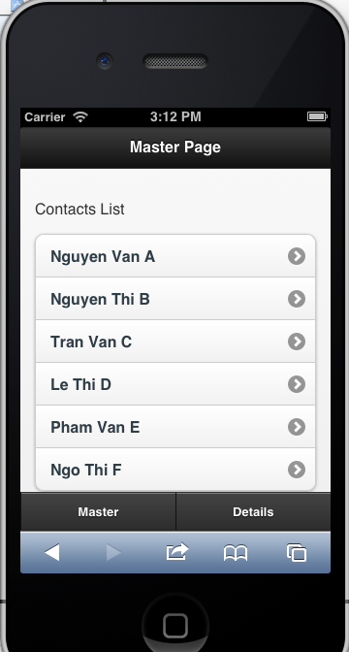

Exercise 3: Create responsive layout in detail page.

Description
The purpose of this exercise is make students get familiar with how to make the responsive layout in different device’s resolution and orientation. This makes use of the power of media queries of CSS3.

Requirement of Details page
We will create 4 <div> sections specified for the logo, person info, contacts info, and his/her interests.

The screen layout in portrait orientation will look like below
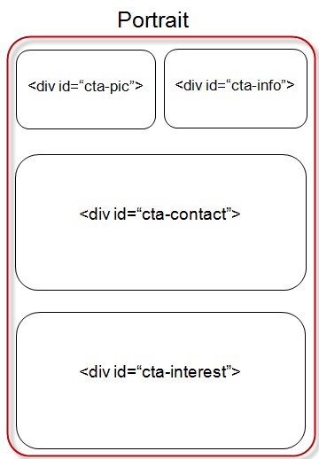
The screen layout in landscape orientation will look like below
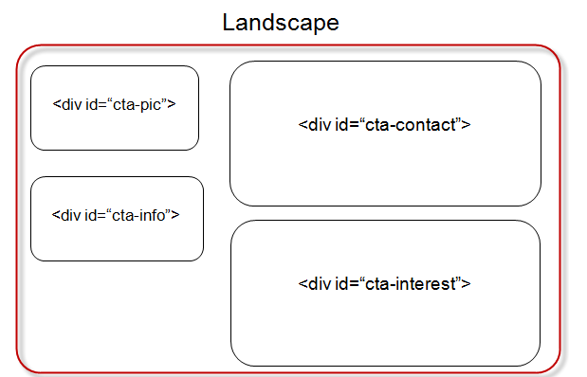

Create contents for detail page
<div class="l50">
<div class="nl50">
<div id="cta-pic"><img src="images/logo.gif" />
</div>
</div>
<div class="nl50">
<div id="cta-info">
<h2>Nguyen Van A</h2>
<h5>Hochiminh City</h5>
</div>
</div>
</div>
<div class="l50">
<div id="cta-contact">
<ul data-role="listview" data-theme="d" data-divider-theme="e" data-inset="true">
<li data-role="list-divider">
Contact Information
</li>
<li>
<h3>Phone number</h3>
<p>
Office: 555-555-5555 ext. 512
</p>
</li>
<li>
<h3>Email</h3>
<p>
developer@emailaddress.com
</p>
</li>
<li>
<h3>Websites</h3>
<p>
http://www.mywebsite.com
</p>
<p>
http://www.myotherwebsite.com
</p>
</li>
</ul>
</div>
<div id="cta-interests">
<ul data-role="listview" data-theme="d" data-divider-theme="a" data-inset="true">
<li data-role="list-divider">
Interests
</li>
<li>
Mobile Development
</li>
<li>
Technology
</li>
<li>
Media
</li>
</ul>
</div>
</div>

</div>

Create style sheet for responsive layout
Open main.css file and put the styles as below
img {
max-width: 100%;
}
.nl50 {
float: left;
width: 50%;
}
.l50 {
float: none;
width: 100%;
overflow: hidden;
}
@media all and (min-width: 400px) {
.nl50 {
float: none;
width: 100%;
}
.l50 {
float: left;
width: 50%;
}
}

Run the details page in iPhone simulator
- Portrait mode:

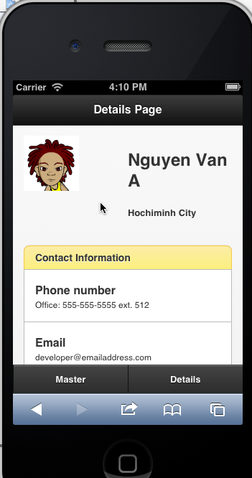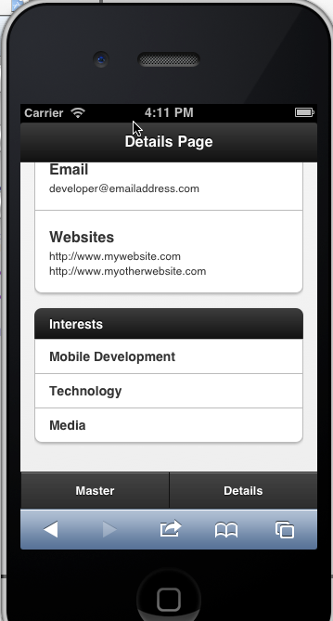

- Landscape mode:
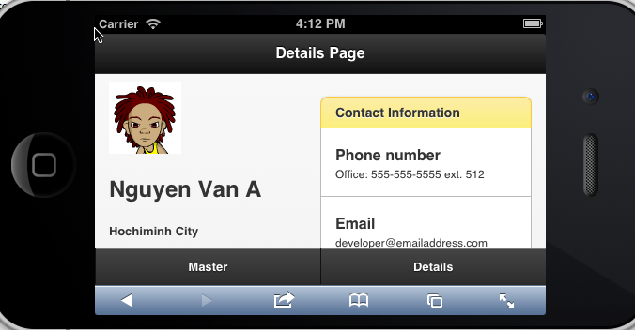
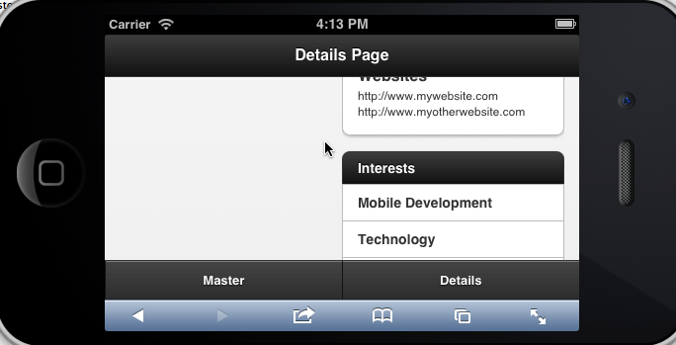

4. Homework
Duration: one week
Requirement:
With the application above, please do some extra exercises below:
- Change the contacts.js file for more meaningful value.
- Change the structure so that there’s only a Master page shown when the site is first loaded. (Remove the navbar at the footer)
- Make changes on the Listview so that when clicking on the Listview item in Master page, the screen will show the Details page in which the detail information of the selected contact is displayed correspondingly. Note, also show the Back button in detail page so that user can turn back to the Master page.

